Human rights violations committed by the Wagner Group and Host Nations

Fidel Nkwocha

College of Information Science and Technology

University of Nebraska at Omaha

Omaha, NE 68182

fnkwocha@unomaha.edu

**Abstract**

In some parts of the World where governments have lost control over their territories, mercenaries have emerged as the new rulers of the land. They operate freely, without any fear of repercussions, taking on contracts from anyone willing to pay their exorbitant fees. The once peaceful cities and towns have now become battlegrounds, with mercenaries fighting for dominance and control. The people have become pawns in this deadly game, caught between the crossfire of rival factions. One of the most recent mercenary organizations is known as the Wagner Group. It is a private military company that has gained notoriety in recent years due to its involvement in conflicts around the world. The group is believed to be linked to the Russian government, and its activities have raised concerns about the use of mercenaries in modern warfare. The White House national security council spokesman, John Kirby, called Wagner “a criminal organization that is committing widespread atrocities and human rights abuses.” The purpose of this article is to identify and explore some of the most egregious violations committed by the Wagner Group and the host nations that have allowed them to operate within their borders.

# The Wagner Group

**A. History and background of the Wagner Group**

The Wagner Group was founded in 2014 by Yevgeny Prigozhin, a Russian businessman with close ties to President Vladimir Putin. Prigozhin is also known as "Putin's chef" due to his catering business that has provided food for the Kremlin. The group's name is believed to be a reference to the German composer Richard Wagner, who was admired by Adolf Hitler.

The Wagner Group's first known operation was in Ukraine, where it fought alongside Russian-backed separatists in the Donbass region. The group's fighters were initially referred to as "little green men" due to their unmarked uniforms and lack of insignia. The Wagner Group's involvement in Ukraine has been linked to the annexation of Crimea by Russia in 2014.

Wherever the Wagner Group goes, they are accused of the arbitrary killing of civilian non-combatants, including through deadly land-mining of conflict zones, looting and corruption [1]. They also prop up political thugs often of a military dispensation, and variously using torture, selective assassination and bullying, and the picture that emerges from the shadows is not pretty. As usual, one of the benefits of employing a private military company (PMC) like the Wagner Group is that when things go awry, the government that hired the PMC can deny having anything to do with the situation.

**B. Structure of the Wagner Group's operations**

The exact structure of the Wagner Group is unclear, but it is believed to be a subsidiary of the Russian private military company RSB Group. The group is also thought to be closely linked to the Russian military intelligence agency GRU. The Wagner Group is believed to be composed of several thousand fighters, many of whom are veterans of the Russian military.

As shown in Fig. 1.1, the Wagner Group boasts significant involvement in the African continent in multiple capacities. It has been involved in conflicts in several countries, including Syria, Libya, and the Central African Republic. In Syria, the group has fought alongside the Syrian government forces and has been accused of committing war crimes against civilians. In Libya, the group has been accused of supporting the Libyan National Army, which is led by General Khalifa Haftar. The group has also been involved in the conflict in the Central African Republic, where it has been accused of human rights abuses. The group’s operations have raised concerns about the use of mercenaries in modern warfare. The group's fighters are not subject to the same regulations and accountability as regular soldiers, and their involvement in conflicts can blur the lines between state and non-state actors.

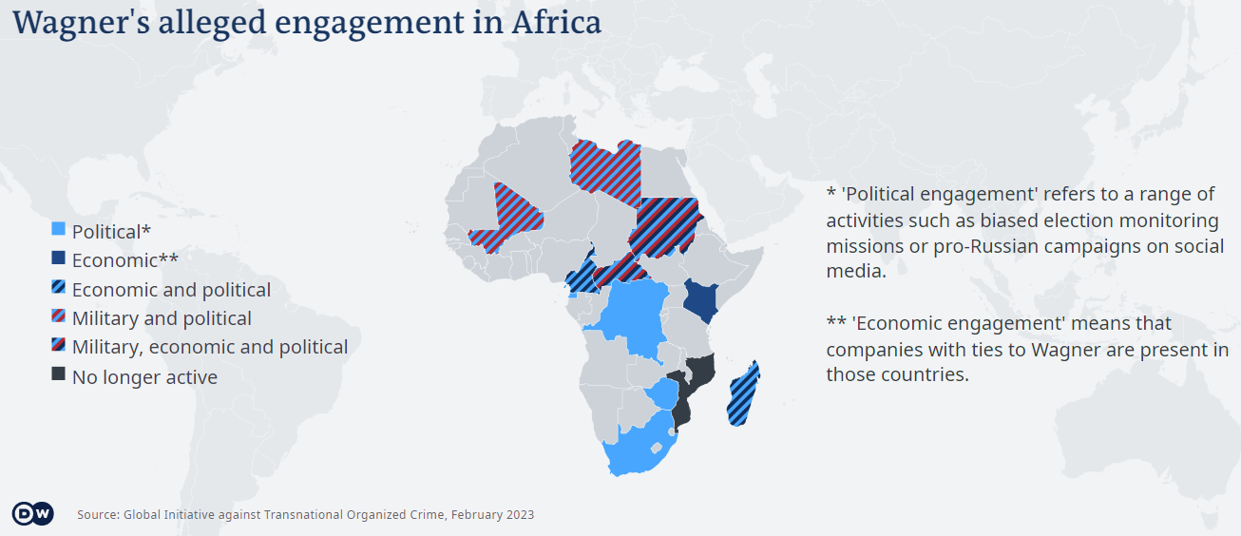

Fig 1.1. Wagner Group presence in Africa [8]

**C. Human rights violations committed by the Wagner Group**

Although the Wagner Group likes to keep its operations undetected, there are organizations who have devoted substantial resources in tracking and exposing the works of the Wagner Group. *Fig. 1.2* shows us some of the known movements of the Wagner Group. The host nations that have allowed the Wagner Group to operate within their borders have also been complicit in human rights violations. Here are some of the publicly available reports on human rights violations:

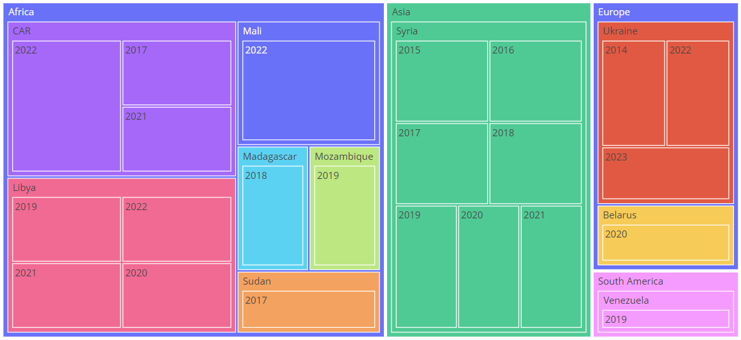

Fig 1.2. Wagner Group movement based on dataset constructed from web searches.

Central Africa Republic

Wagner’s activities in the Central African Republic (CAR) provide the most well-documented example of civilian harm. Since Wagner arrived in the country, its troops were implicated in crimes against local populations, including frequent rapes of teenage girls in villages near its operating bases. Wagner-linked atrocities in the CAR multiplied as PMC troops became increasingly involved in combat operations. According to reports by the Human Rights Watch organization, the Wagner Group was involved in the training and arming of the country's security forces and was also allegedly involved in extrajudicial killings, torture, forced and disappearances from 2021 to 2022 [3]. In one incident, the Wagner Group beat and kicked men while they were lying on the ground. Then pulled up the civilians one by one, forced them to kneel, and shot them in the head. Those watching others being killed started to pray out loud.

And in October 2021, seventeen UN experts said they received reports that the Wagner Group, who were operating as military and security personnel, violently harassed and intimidated peacekeepers, journalists, aid workers [3].

Libya

According to Amnesty International, the Libyan National Army (LNA), in conjunction with the Wagner Group, committed serious human right violations in Libya [4]. These violations include acts of retaliation such as the use of anti-personnel landmines in flagrant violation of the international ban. The two armies placed anti-personnel landmines as they withdrew from the neighborhoods of Ain Zara and Salah el-Din south of Tripoli. At least one civilian was killed when he returned to his family house by a landmine that was planted in his family house according to his family. The Human Rights Watch documented the deaths of three deminers attempting to dismantle some of these mines [5].

Also, the Wagner Group has been accused of carrying out airstrikes and drone attacks, recruiting child soldiers, and committing extrajudicial killings in Libya. It is also reported that the Wagner Group is involved in the ongoing civil war, supporting forces loyal to the Libyan National Army (LNA) led by General Khalifa Haftar.

[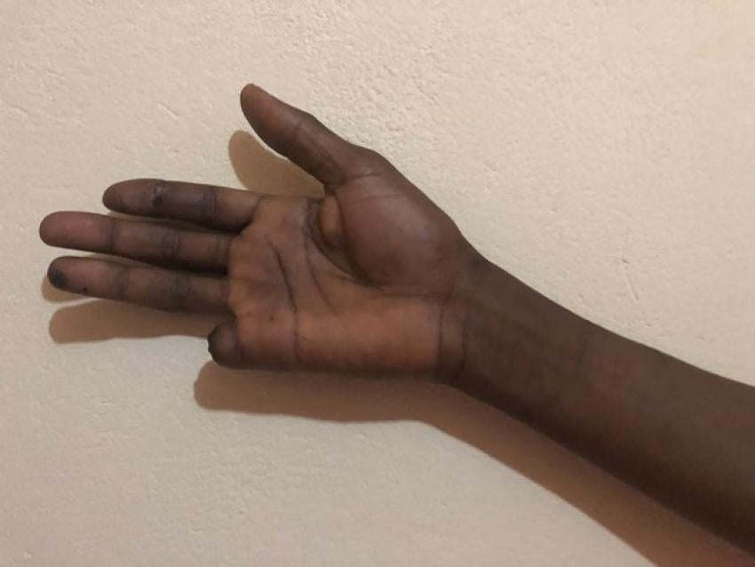](https://www.hrw.org/modal/95898)

Fig 1.3. The right hand of Mahamat Nour Amadou [4]

A civilian named Mahamat Nour Amadou said his finger was cut off by the Russian-speaking forces, as shown in *Fig. 1.3*, in Bambari, Ouaka province, in January 2019. Nour spoke with international media about his case and told Human Rights Watch he feared for his life for speaking out. He was later killed, in September 2019, under unclear circumstances [4]. It is highly likely that this Mr. Nour Amadou was murdered because he spoke up about the brutal tendencies of the Wagner Group.

Mali

The United Nations released a report alleging that the Wagner Group was responsible for human rights violations in Mali. The report stated that violence against civilians increased in number and severity since Wagner's arrival in December 2021 [6]. In the first quarter of 2022, civilian fatalities in the conflict were greater than in all of 2021. Most notably, at the end of March, Malian armed forces (Forces Armées Maliennes, or FAMa), assisted by Wagner troops, massacred more than 300 civilians in the central Malian town of Moura during a five-day siege, making the attack the worst atrocity in the decade-long conflict in Mali.

The United States, Canada, Great Britain and Ukraine are among western countries which have raised concerns over the role of Wagner contractors in supporting Mali's armed forces. The government of Mali, whose leaders seized power in a 2021 coup, and Russia have previously maintained that Russian forces there are not mercenaries but trainers helping local troops with equipment bought from Russia. And Russian President Vladimir Putin has said Mali has the right to work with private Russian firms [7].

Ukraine

According to a report by Human Rights Watch, Wagner Group operatives were involved in the torture and murder of civilians in the Donbass region of Ukraine. The report also documented cases of the Wagner Group using prohibited weapons, such as incendiary munitions. The group is said to have provided military training, equipment, and personnel to pro-Russian separatist forces fighting against the Ukrainian government. In addition to the conflict in eastern Ukraine, the Wagner Group has also been linked to the annexation of Crimea by Russia in 2014.

Furthermore, the Wagner Group is currently active in Ukraine. The group was hired by the Russian government to support separatist forces in the eastern regions of the country. The Wagner Group has been accused of the shelling of civilian areas and the torture and execution of Ukrainian soldiers and civilians. There is a video which seem to imply that Wagner Group beheaded Ukrainian servicemen [11]. And two former Wagner Group members admitted to killing 20 children in Ukraine [12].

Syria

One of the most well-known instances of human rights violations committed by the Wagner Group occurred in Syria. The group was hired by the Russian government to support the regime of Bashar al-Assad in its fight against opposition forces. The Wagner Group has been accused of committing war crimes, including the use of chemical weapons and indiscriminate bombing of civilian areas. The group has also been linked to the torture and execution of Syrian civilians [9].

The Syrian government of Bashar al-Assad has been accused of allowing the Wagner Group to operate with impunity, despite evidence of war crimes committed by the group. In Ukraine, the government of Viktor Yanukovych allowed the Wagner Group to operate within the country, despite evidence of human rights violations committed by the group.

# Conclusion

In a world where governments struggle to maintain order and security, mercenaries have become a common sight. These hired guns operate with little oversight or regulation, taking on jobs that range from protecting wealthy individuals to carrying out covert operations for shadowy organizations. While some see them as a necessary evil in an unstable world, others worry about the potential for abuse and the lack of accountability. Despite the concerns, the demand for mercenaries continues to grow, and some are drawn to the lucrative and dangerous lifestyle. But as the lines between right and wrong become increasingly blurred, it's unclear what the future holds for these mercenaries and the world they operate in.

Because they tolerate human rights abuses and require no accountability from host nations, Wagner and other Russian PMCs are particularly appealing to illiberal regimes that already do not prioritize human rights concerns. Private Military Contractor (PMC) organizations like Wagner justify their actions by claiming to professionalize militaries and in this way somehow contribute to shortening conflicts [1]. If this were true it would make for a puzzling business model as PMCs depend on continuing conflict for their income. Many PMCs and their recruits have ideological inclinations that run to militarism and even extremist white nationalism. Members of the Wagner Group represent themselves as the hard-bitten tough guy yet somehow professional wing of a Russian military. They recruit from white supremacist milieu, particularly the so-called Russian Imperial Movement: ultra-nationalists who advocate tsarist restoration [1].

It is yet to be seen if the international community would take significant action to hold both the Wagner Group and host nations accountable for human rights violations, and to ensure that justice is served for the victims. Thus far, sanctions alone do not seem to be enough to deter these Private Military Contractor organizations.

As a student reporting on the human rights violations of the Wagner Group and Host Nations, I can make a difference by continuing to gather data on this organization and, share every information I find with anyone who would listen. As more and more organizations devote resources to tracking the violations committed by the Wagner Group, and more research projects like this very one continues to shed some light on the publicly available information, there will be greater exposure of the Wagner Group. It is likely that more scrutiny would lead to more serious action from the international community to thwart the operations of this group.

# VI. References

[1] <https://newint.org/features/2023/02/20/hall-infamy-wagner-group>

[2] <https://www.usip.org/publications/2023/04/africa-heres-how-respond-russias-brutal-wagner-group>

[3] <https://www.hrw.org/news/2022/05/03/central-african-republic-abuses-russia-linked-forces>

[4] <https://www.amnesty.org/en/latest/news/2020/06/libya-retaliatory-attacks-against-civilians-must-be-halted-and-investigated/>

[5] <https://www.hrw.org/news/2022/05/31/libya-russias-wagner-group-set-landmines-near-tripoli>

[6] <https://www.csis.org/analysis/massacres-executions-and-falsified-graves-wagner-groups-mounting-humanitarian-cost-mali>

[7] <https://www.msn.com/en-sg/news/world/western-countries-pile-pressure-on-mali-over-wagner-group-role/ar-AA1aEird>

[8] <https://www.dw.com/en/pmc-russias-wagner-group-in-sudan-gold-military-junta/a-65439746>

[9] <https://www.fidh.org/en/region/north-africa-middle-east/syria/syria-russia-wagner-appeal-european-court-human-rights>

[10] <https://en.wikipedia.org/wiki/Wagner_Group>

[11] <https://www.newsweek.com/wagner-group-accused-beheading-ukrainian-servicemen-1793776>

[12] <https://www.politico.eu/article/former-wagner-group-commanders-azmat-uldarov-alexey-savichev-confess-murder-ukraine-civilians-including-children/>